**PROJECT TITLE**

**SLA Management for Hardware Group - Priority 4**

**Project Description:**

To implement and manage an SLA in ServiceNow for hardware-related incidents categorized as Priority 4, ensuring incidents are addressed within 16 business hours, pausing the SLA when the incident is on hold, and stopping the SLA when the incident is resolved or closed.

**Team members**

* Gokul P
* Thanush kumar G
* Karrupusamy S
* Sidharthn S

**Implementations**

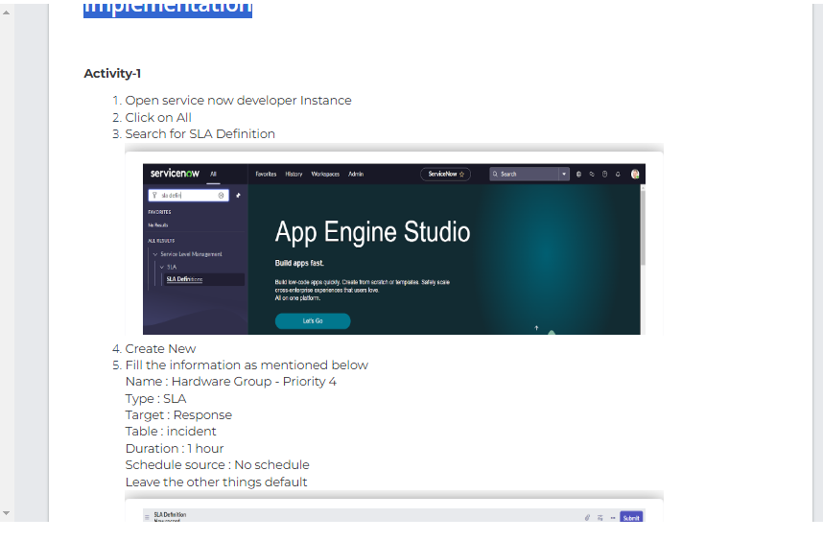

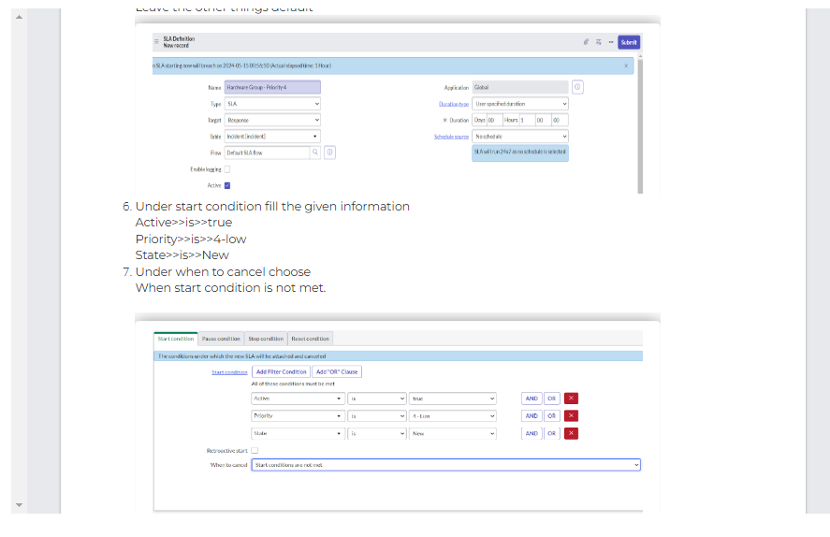

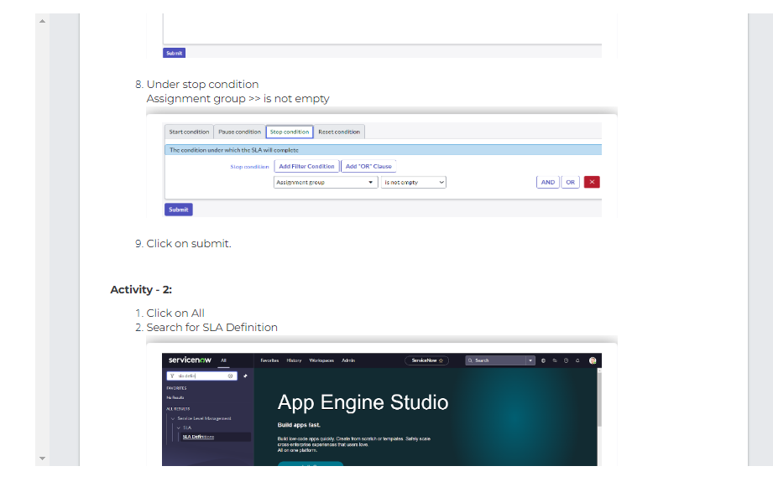

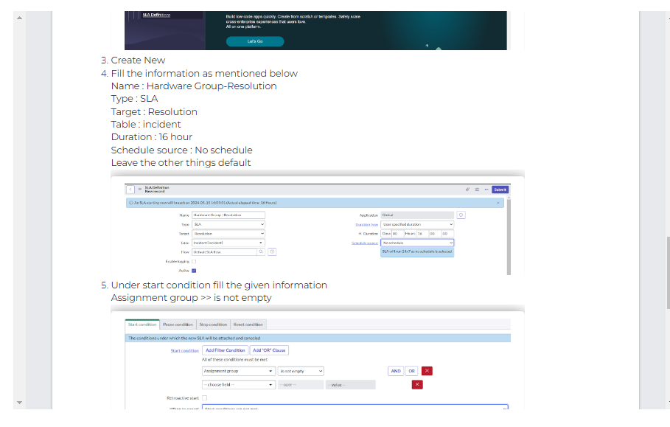

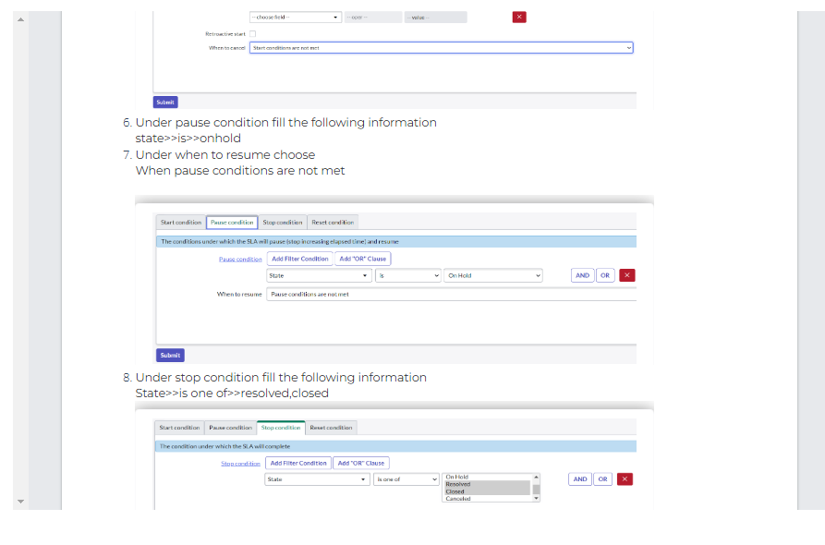

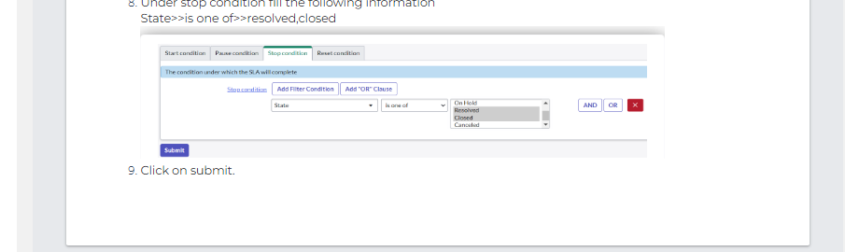

**Activity 1 output**

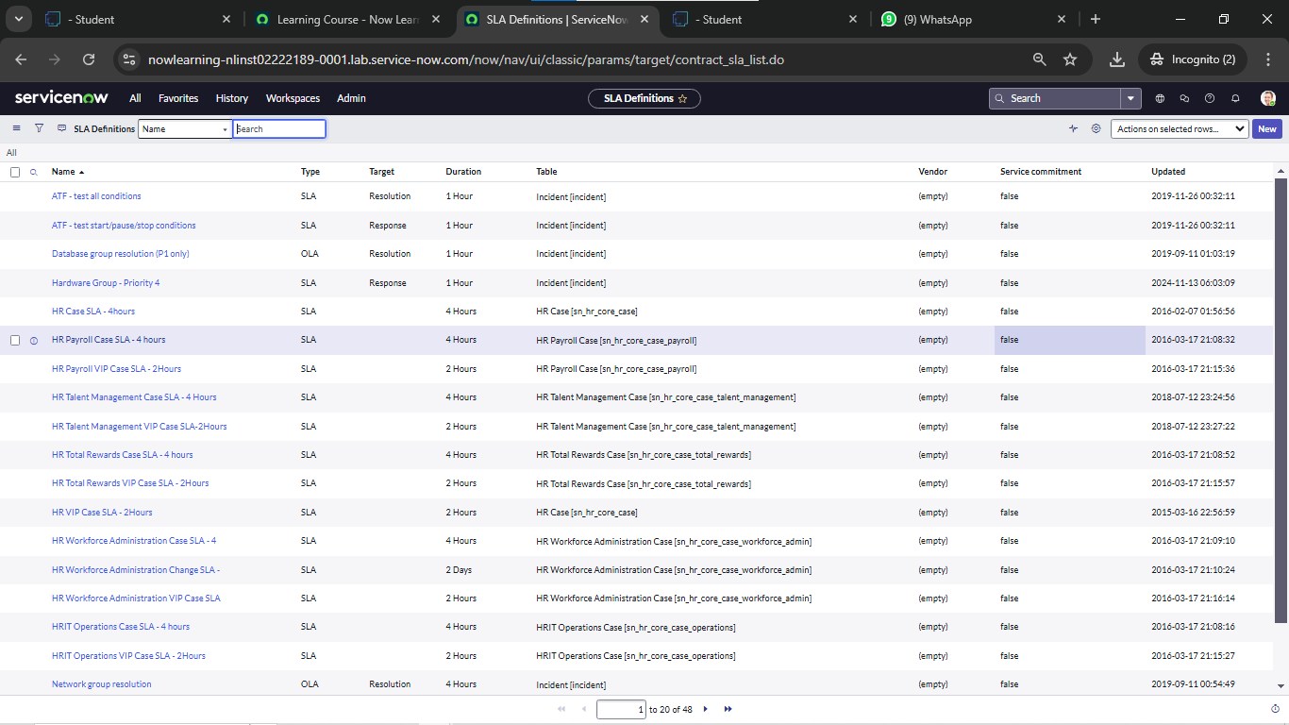

**Activity 2 output**

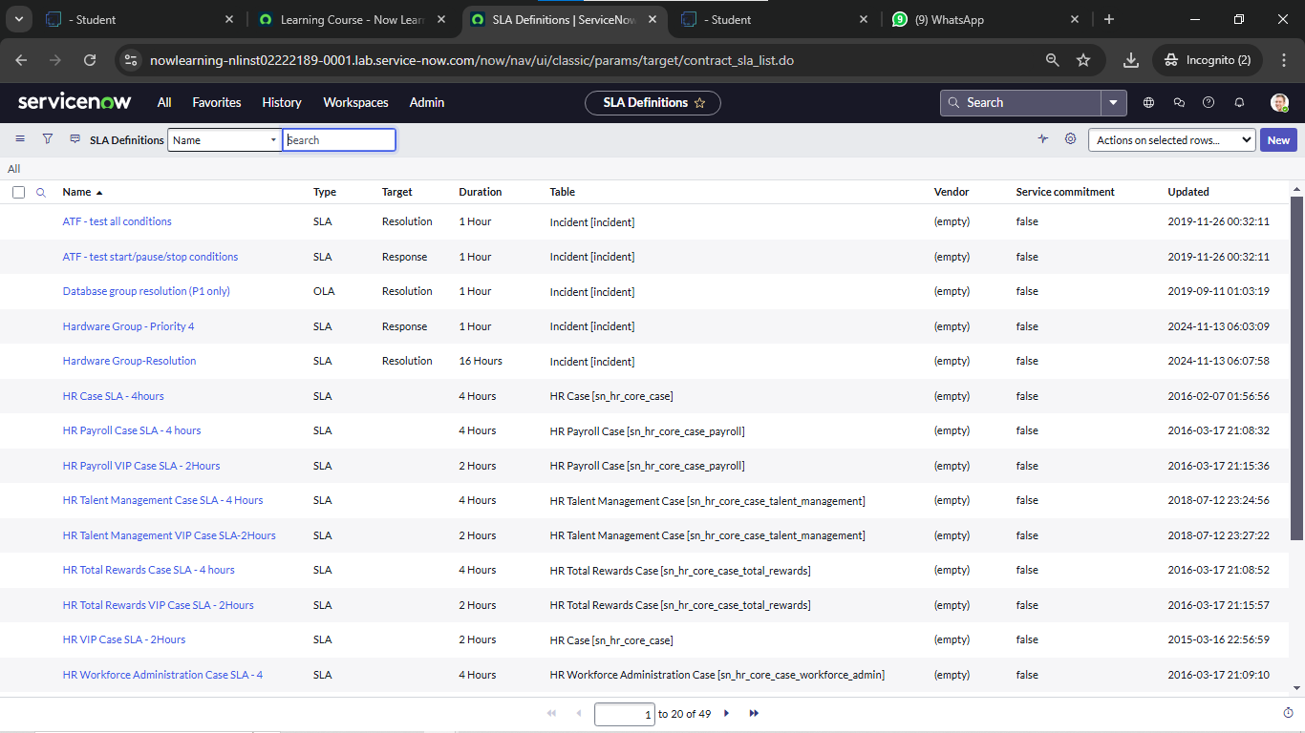

**Result implementaion**

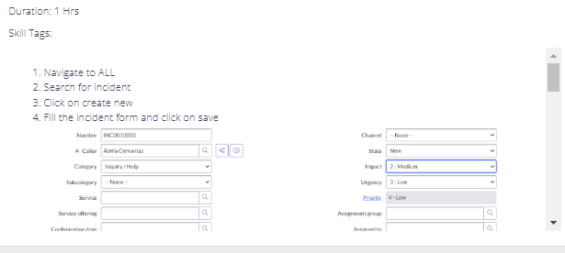

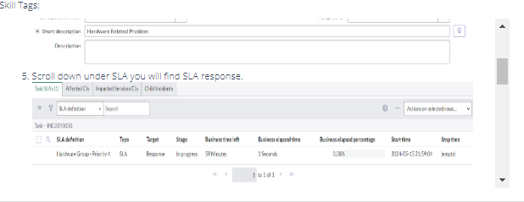

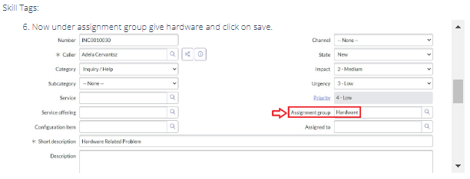

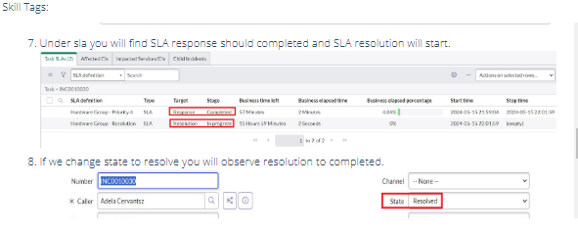

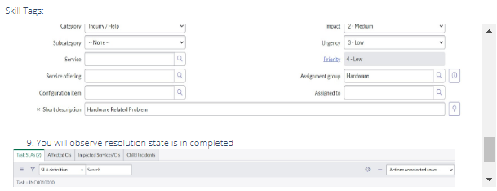

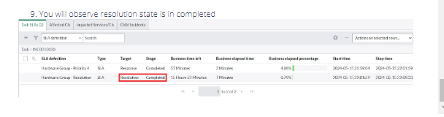

**Result Output**

